COMP3111 Activity 1

WANG Yanbang (20329177)

[ywangdr@connect.ust.hk](mailto:ywangdr@connect.ust.hk)

Use-case Detailed Specifications for Task 1 & Task 6

**Task 1 – Backend:**

**Brief Description:**

While Task 1 is not a complete use case, it is closely associated with the use case of scraping the course list, either for certain course information, or error message when 404 error occurs .

**Use-case diagram:**

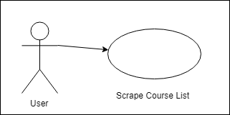

**Basic Flow:**

**{User Input}**

1.The user go to the *Main* tag, input the base URL, term and subject.

**{Ready to search}**

2. The user clicks the *Search*

**{Display scraped information}**

3. the user can view the requested course-related information from the console output. Such information should include course titles, course code, sections, time slots, as well as NUMBER_OF_COURSES, NUMBER_OF_SECTIONS, and Instructors who have teaching assignment this term but do not need to teach at Tu 3:10pm.

4. The use case ends.

**Alternative Flows**

***A1: User-specified webpage is not found (i.e., a 404 error returned)***

At **{Display scraped information}**, If the user-specified webpage is not found

1. An error message is shown in a popped-up window.

2. The user closes the window, and returns to **{User Input}**

***A2: Use Default Webpage URL***

At **{User Input}**, if the user chooses leave the default SFQ URL unchanged

1. The user skips the step 1 and starts from **{Ready to search}** to continue the use case.

**Task 6 - SFQ:**

**Brief Description:**

This use case describes how a user(student) can use the software to scrape SFQ information from a specified website and views the scraped information

**Use-case diagram:**

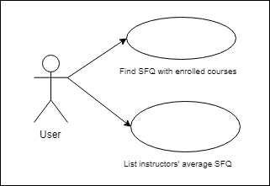

**Basic Flow:**

1. The use case begins when the selects SFQ tab, and given that *search* or *All Subject Search* has been clicked.

**{Enter url}**

1. The user enters a SFQ URL.

**{Ready to Scrape}**

2.1 If the user clicks *Find SFQ with enrolled courses*,

**{Page Retrieved & SFQ-enrolled Parsed}**

2.1.1 the user views unadjusted SFQ data of his/her enrolled course, which are scraped from the URL and displayed on the console

2.2 If the user clicks *List instructors' average SFQ,*

**{Page Retrieved & SFQ-instructor Parsed}**

2.2.1 the user views all instructors' name and their unadjusted SFQ score from the console

3. The use case ends

**Alternative Flows**

***A1: SFQ webpage not found***

At either **{Page Retrieved & SFQ-enrolled Parsed}** or**{Page Retrieved & SFQ-instructor Parsed}**, if the user-specified webpage is not found,

1. An error message is shown in a popped-up window.

2. The user closes the window, and returns to **{Enter url}**

***A2: Use Default Webpage URL***

1. At **{Enter url}**, the user can choose to use leave the default SFQ URL unchanged
2. The user skips the step 2 and starts from **{Ready to Scrape}** to continue the use case.